<https://github.com/mattboldt/typed.js>

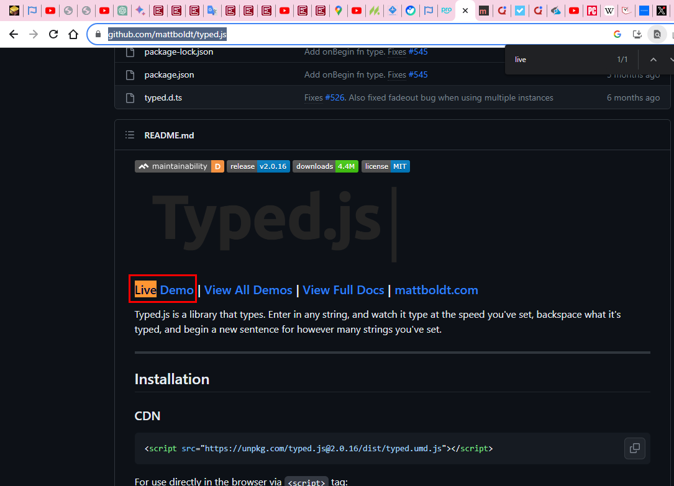

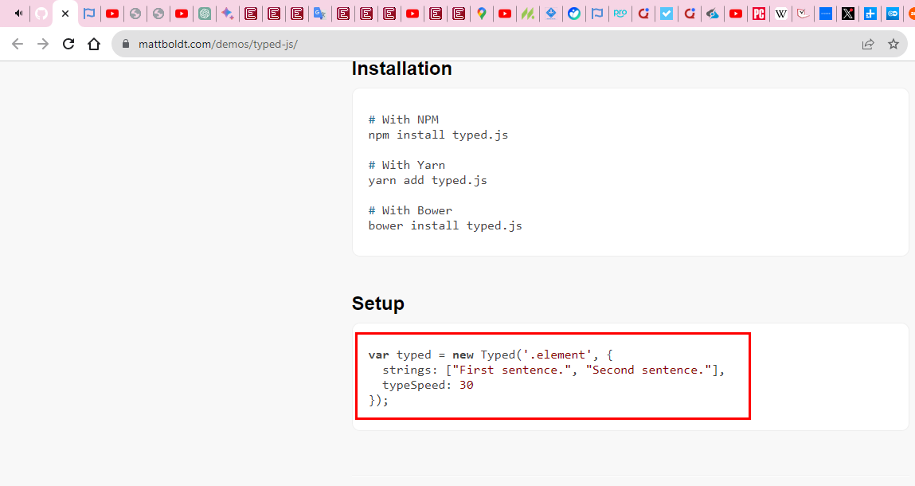

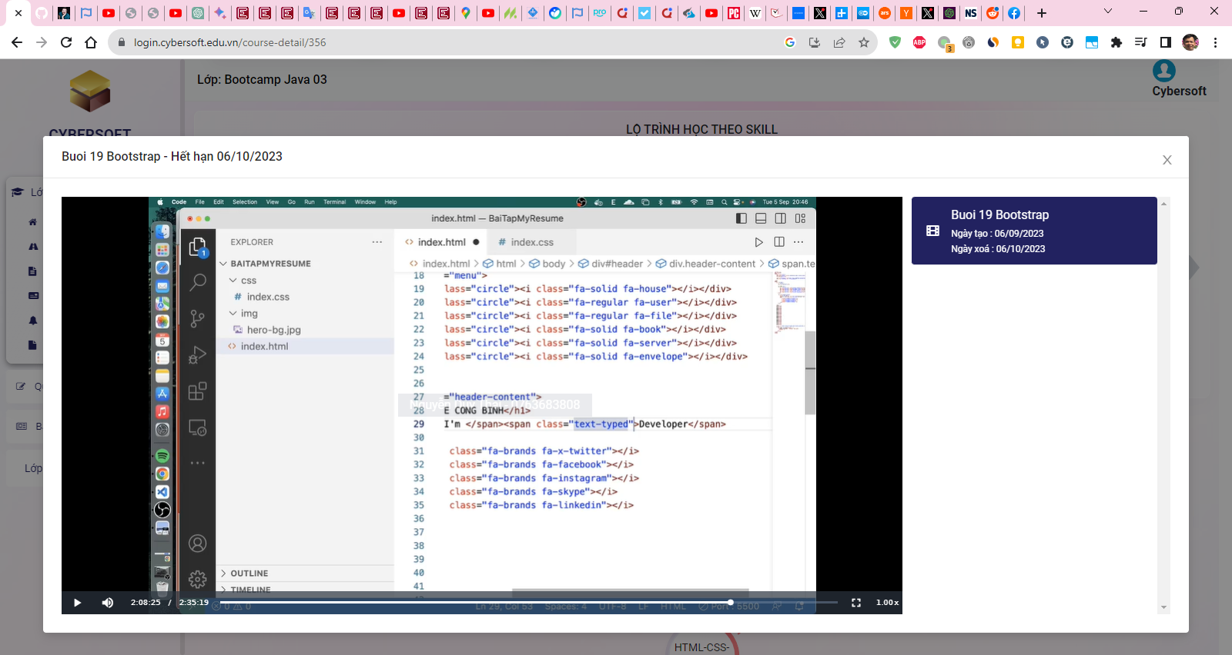

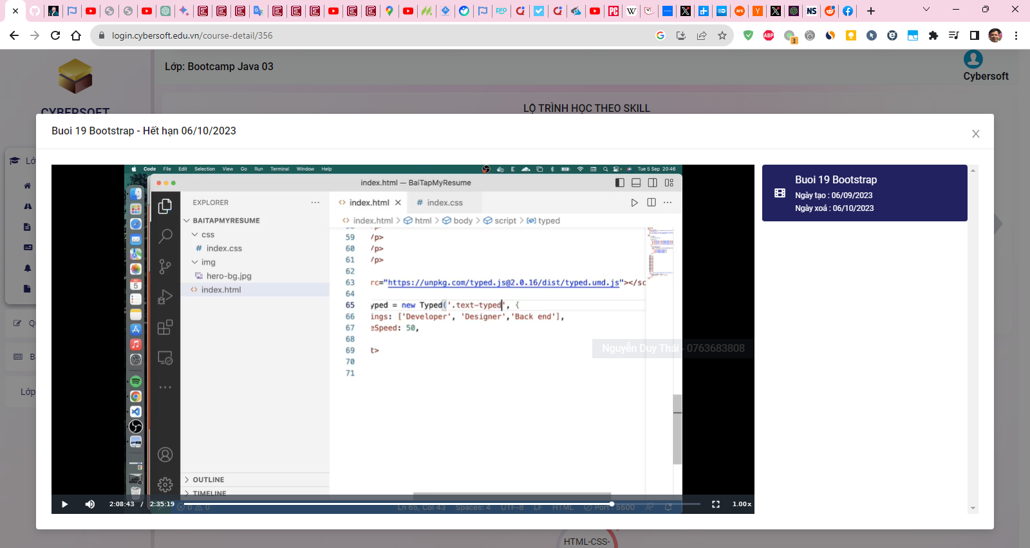

I want to apply Typed.js Javascript library into span tag

<span class="text-typed">developer</span>

However, when I browse typing.html then Typed.js library does not have effect to text. Fix the issue.

<http://127.0.0.1:3000/web/portfolio/typing.html>

I'm developer var typed = new Typed('.text-typed', { strings: ["developer", "Designer", "Fullstack"], typeSpeed: 30 });

# BEGIN typing.html

<!DOCTYPE html>

<html lang="en">

<head>

    <meta charset="UTF-8">

    <meta name="viewport" content="width=device-width, initial-scale=1.0">

    <title>Document</title>

</head>

<body>

    <span>I'm </span><span class="text-typed">developer</span>

    <script src="https://unpkg.com/typed.js@2.0.16/dist/typed.umd.js"></script>

    var typed = new Typed('.text-typed', {

        strings: ["developer", "Designer", "Fullstack"],

        typeSpeed: 30

      });

</body>

</html>

# END typing.html

Ans1:

It appears that you have not placed the JavaScript code inside a <script> tag. That's why the Typed.js library isn't having any effect on the text. Here's how to fix the issue:

<!DOCTYPE html>

<html lang="en">

<head>

    <meta charset="UTF-8">

    <meta name="viewport" content="width=device-width, initial-scale=1.0">

    <title>Document</title>

</head>

<body>

    <span>I'm </span><span class="text-typed">developer</span>

    <script src="https://unpkg.com/typed.js@2.0.16/dist/typed.umd.js"></script>

    <script>

        var typed = new Typed('.text-typed', {

            strings: ["developer", "Designer", "Fullstack"],

            typeSpeed: 30

        });

    </script>

</body>

</html>

I added the <script> tag to wrap around your JavaScript code. This should allow the Typed.js library to function correctly.

